Taylor Stapus

CS 340

Module 5

04/05/2025

**Client-Side Authentication**

1. **Import CRUD Python Module**

1. **Add unique HTML Identifier**

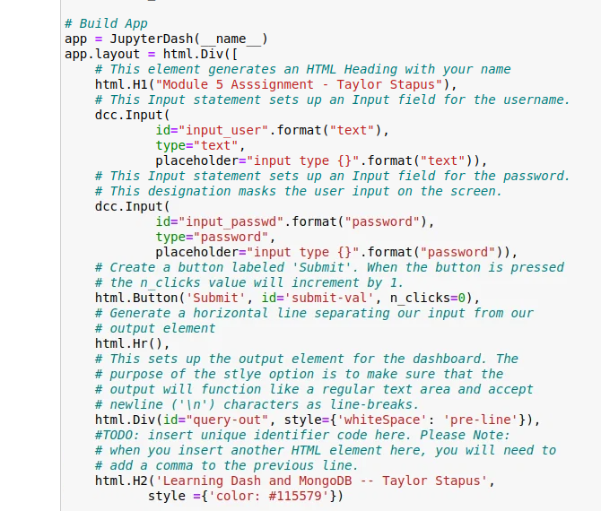

1. **Add functionality in the callback routine for instantiation of the CRUD object.**

**Add functionality to test the dashboard connection to MongoDB**

